Name: Devang Dedhia Department: CYSE
Div: BE-15 Roll No: 66

Subject: Mobile Forensics

Experiment No: 3

Date of  Performance: | 06/02/2025
Date of Submission: | 27/02/2025
Program formation/ Execution/ ethical  practices (06) | Timely Submission (01) | Viva Answer (03) | Total Experiment Marks  (15) | Teacher Signature with date

Experiment No. 3
Aim: Android Data Recovery by parsing/file carving and using forensics tools such as AFLogical/Autopsy
Lab outcome: Explore fundamentals of Practical mobile forensics.

Theory:
1. Introduction to Android Data Recovery
Android devices store a vast amount of user data, including messages, call logs, media files, and application data. Due to accidental deletion, system crashes, or forensic investigations, recovering lost or deleted data is a crucial aspect of digital forensics. One of the primary methods used in Android data recovery is file carving, which involves reconstructing deleted or fragmented files based on known file structures and signatures.
2. File Carving in Digital Forensics
File carving is a technique used to recover files without relying on file system metadata. It involves scanning raw disk or memory dumps to identify file signatures and extract recoverable data. Since Android devices often use ext4, YAFFS2, or F2FS file systems, deleted files may not be directly accessible but can still exist in unallocated space, making file carving an effective recovery method.
2.1 How File Carving Works
- Signature-Based Carving: Identifies files using predefined headers and footers (e.g., JPEG files start with FFD8 and end with FFD9).
- Fragmentation Handling: Some forensic tools attempt to reconstruct fragmented files by analyzing data patterns.
- Data Recovery without File System Metadata: Unlike conventional recovery methods that rely on file tables, file carving works directly on raw data, making it useful for damaged or formatted storage.
3. Autopsy as a Digital Forensic Tool
Autopsy is an open-source digital forensic tool widely used for investigating file systems and recovering deleted data. It provides a graphical interface for The Sleuth Kit (TSK), allowing examiners to analyze disk images and extract valuable evidence.
3.1 Features of Autopsy for Android Data Recovery
- File System Analysis: Supports EXT4, YAFFS2, and F2FS used in Android storage.
- Deleted File Recovery: Identifies and reconstructs deleted files.
- Keyword Searching: Finds specific file types or strings within raw data.
- File Carving with Scalpel or Bulk Extractor: Extracts multimedia, documents, and database files from unallocated space.
- SQLite Database Analysis: Recovers messages, call logs, and app-related data stored in SQLite databases.
3.2 Using Autopsy for Android Data Recovery
- Load the Android Image: Acquire a forensic image of the Android device’s storage (e.g., via ADB, TWRP, or chip-off techniques).
- Analyze File System: Use Autopsy’s file analysis tools to locate deleted files.
- Perform File Carving: Apply Autopsy’s carving capabilities to recover media files, documents, and logs.
- Extract SQLite Databases: Inspect databases for chat history, contacts, and browser activity.
- Generate Forensic Report: Autopsy provides detailed reports on recovered data, aiding forensic investigations.
4. Importance of Android Data Recovery in Forensics
Recovering data from Android devices is critical for various applications, including:
- Criminal Investigations: Recovering messages, call logs, and images as evidence.
- Accidental Deletion Cases: Restoring lost files for personal use.
- Corporate Investigations: Analyzing employee devices for security breaches.

Output:

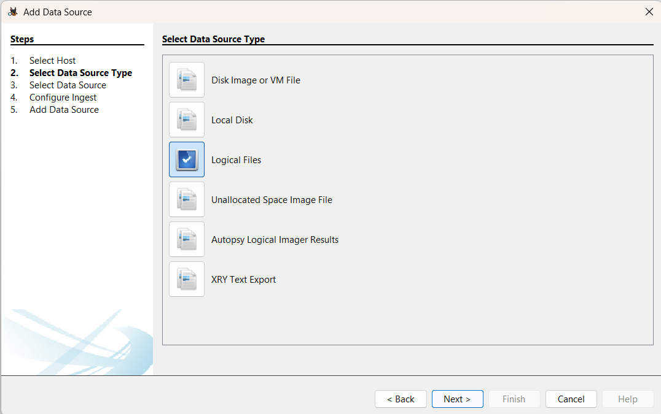
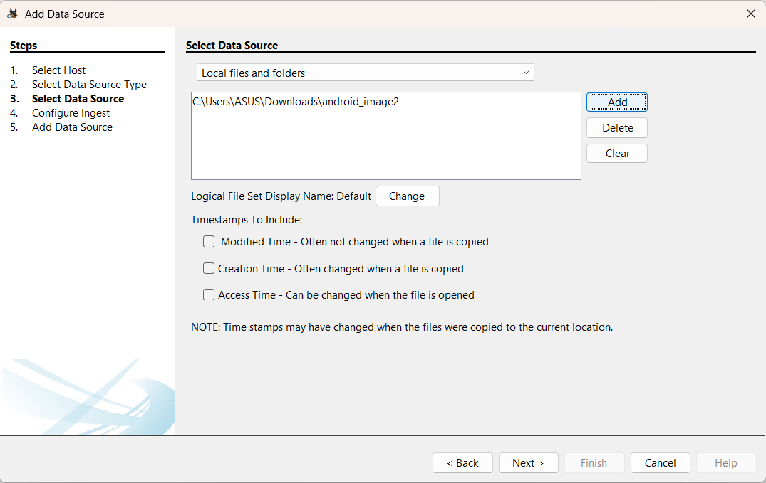

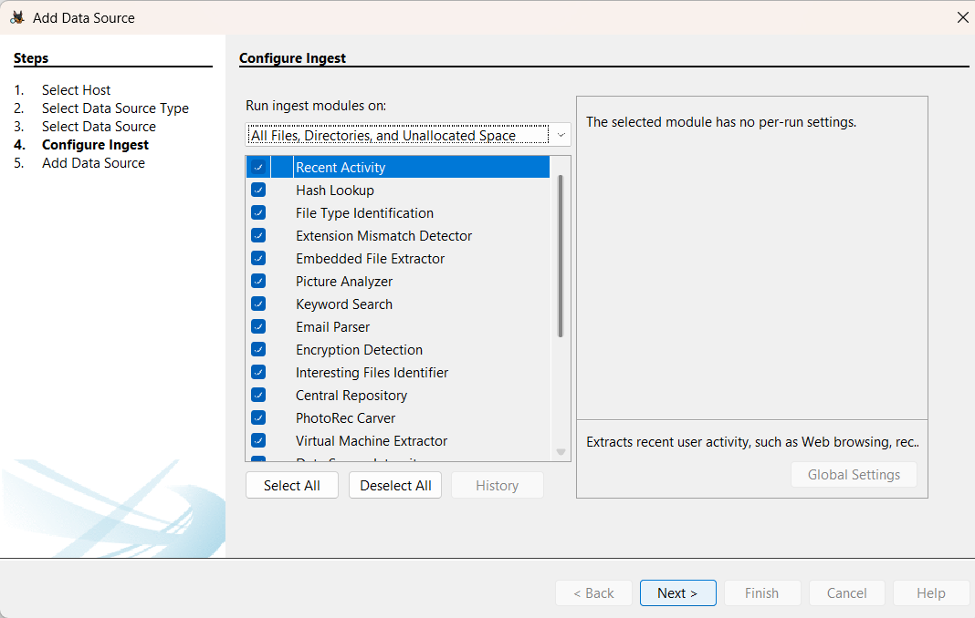

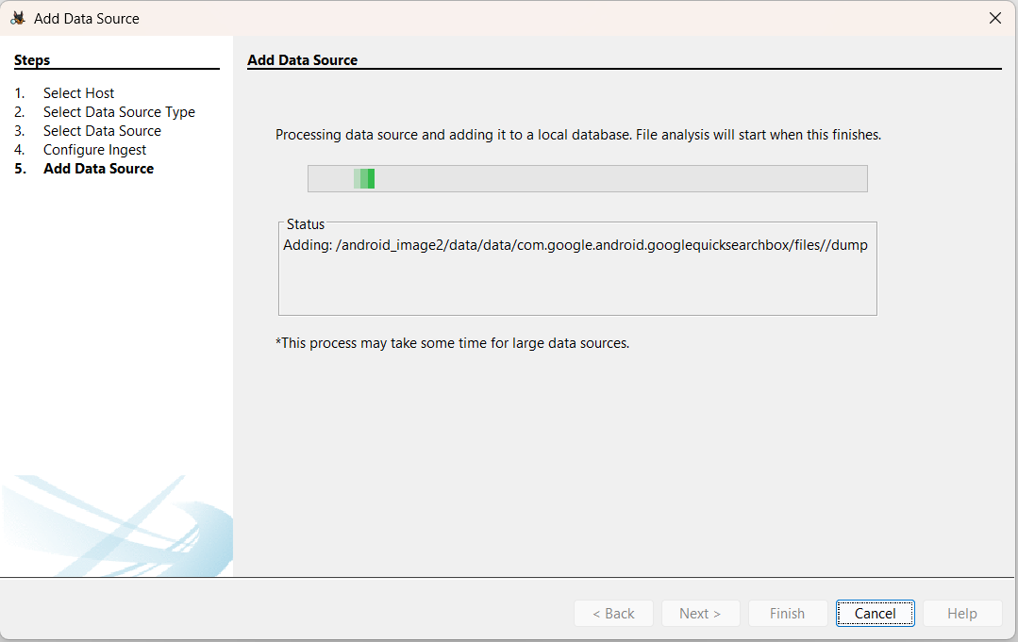

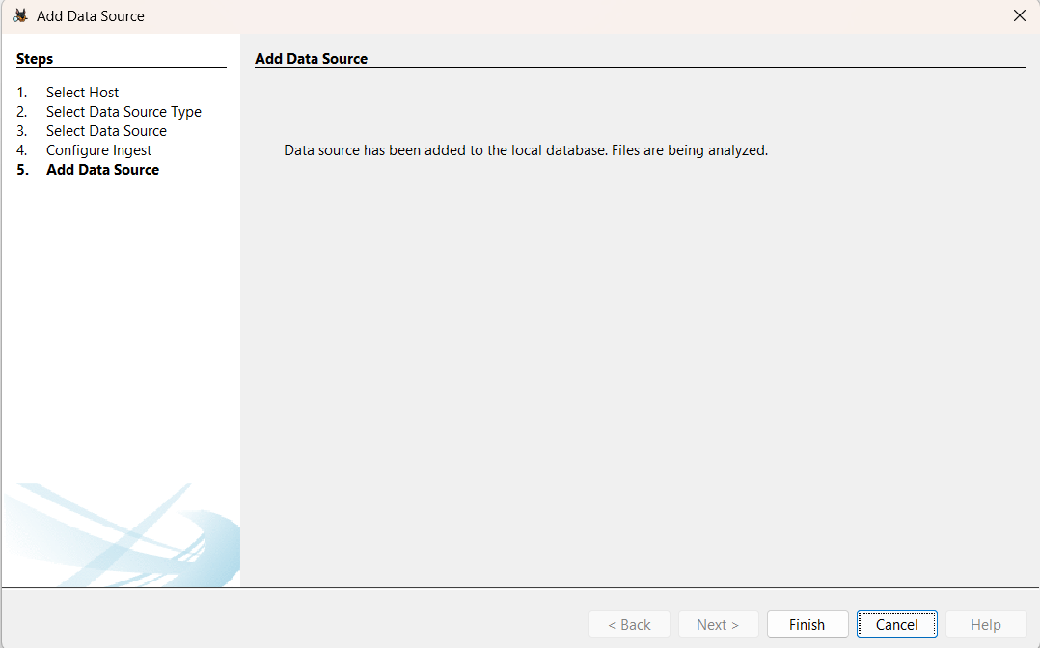

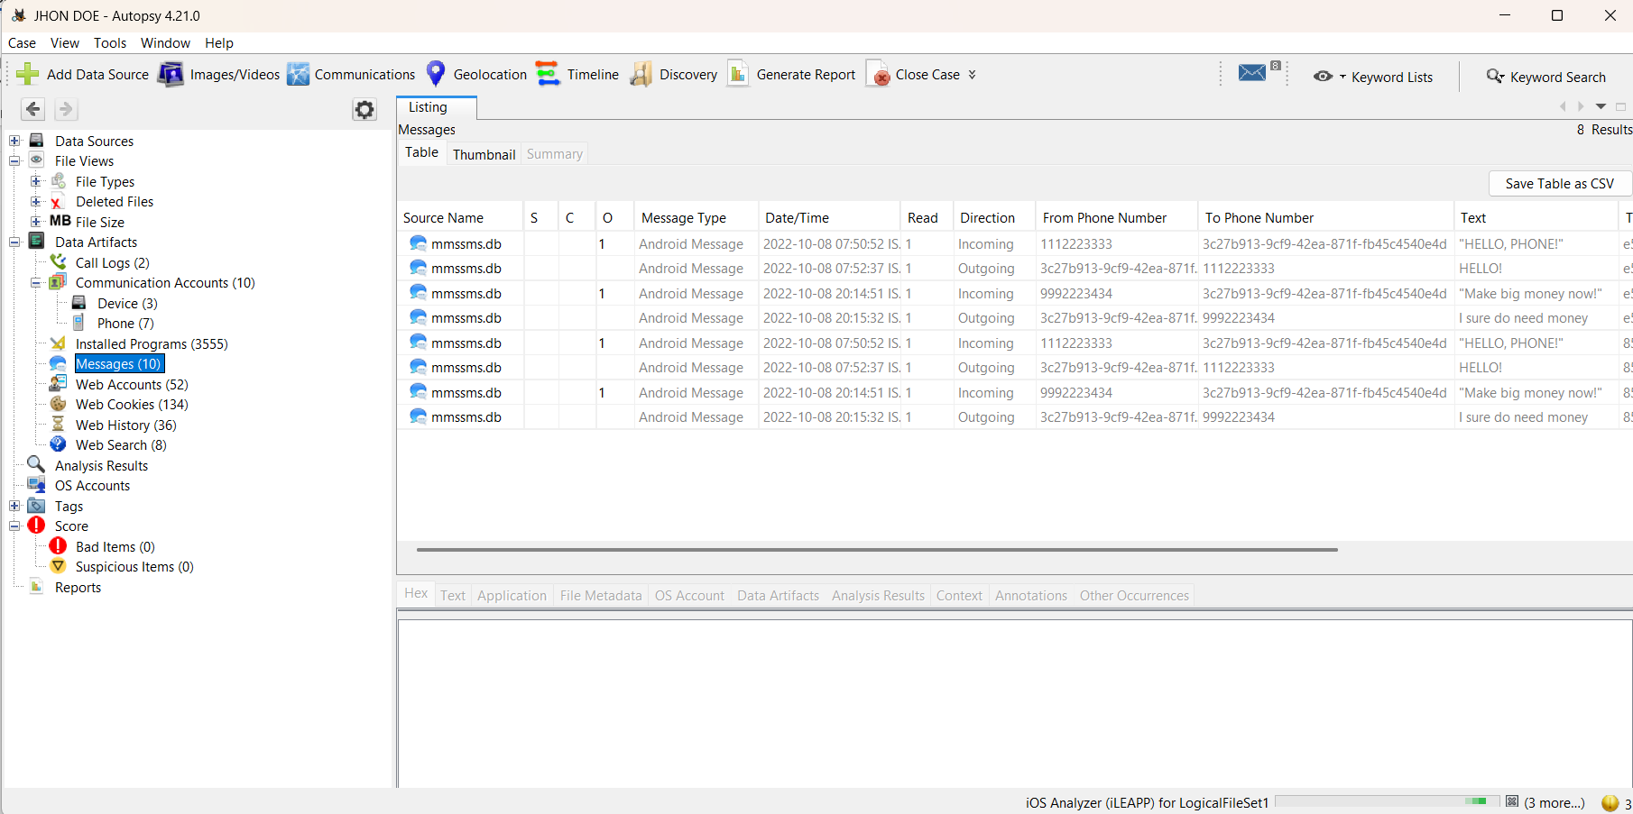

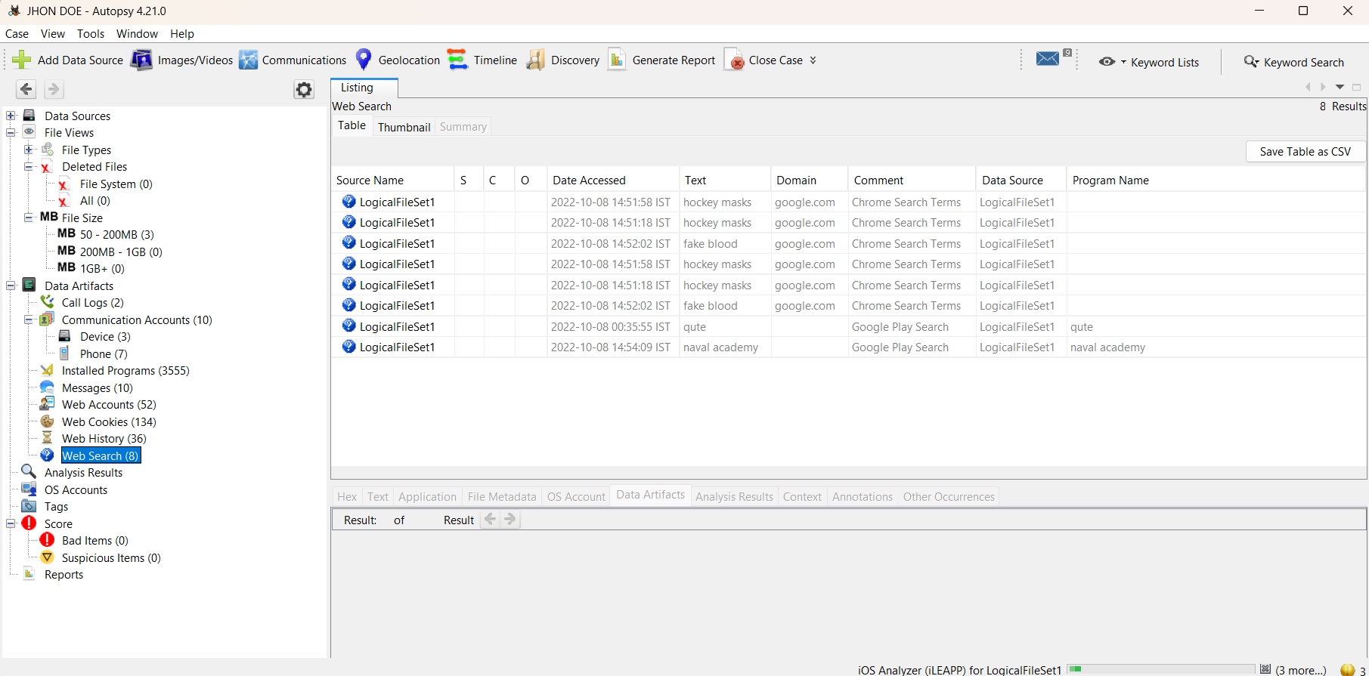

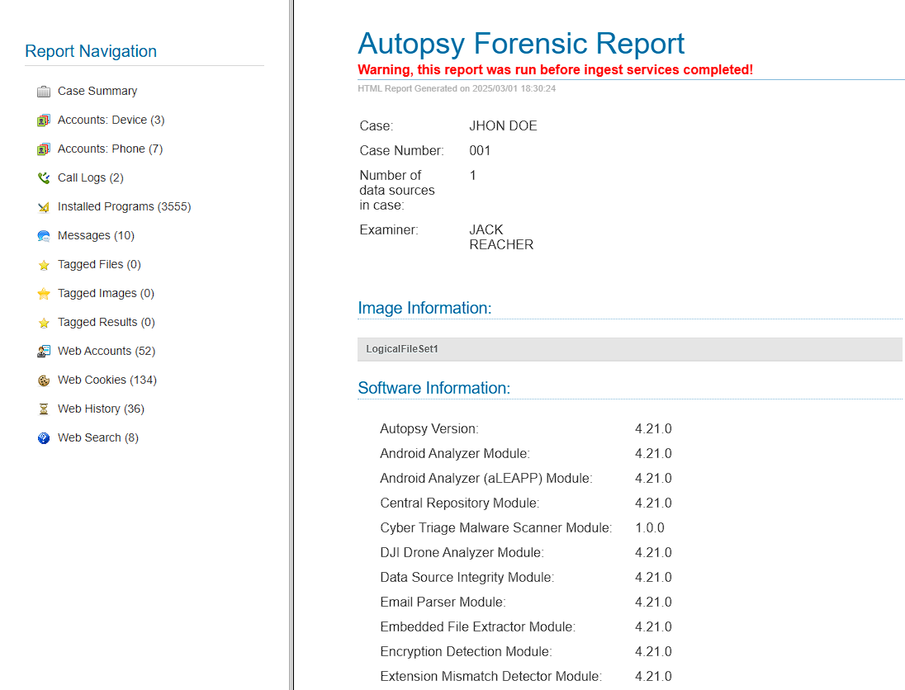
Conclusion:
We have performed evidence extraction on Android device using Autopsy Tool.

